**Device simulation Lab :Assignment 5**

Bukya Anil kumar

EE22M302

Lab No:5

Software: Matlab 2022a

Numerical solution of Poisson’s equation with Maxwell-Boltzmann distribution of

carrier density:

Qa. Assuming electrons as the only type of carriers and an undoped semiconductor,

write the appropriate form of poisson’s equation for electrostatics (assume that the

current is zero, and Maxwell-Boltzmann statistics for carriers).

Ans:

∇2V = −ρ/epsilon.

Qb. Discretize the above equation such that finite difference method could be used to

solve the same.

ANS:

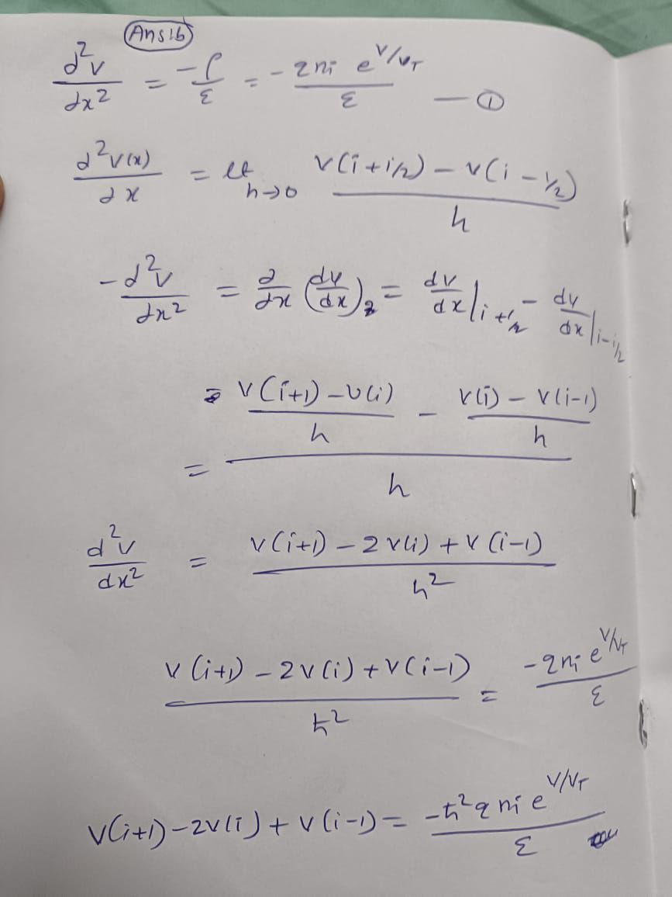

Qc. List out the general form for Jacobian for the above set of equations.

ANS:

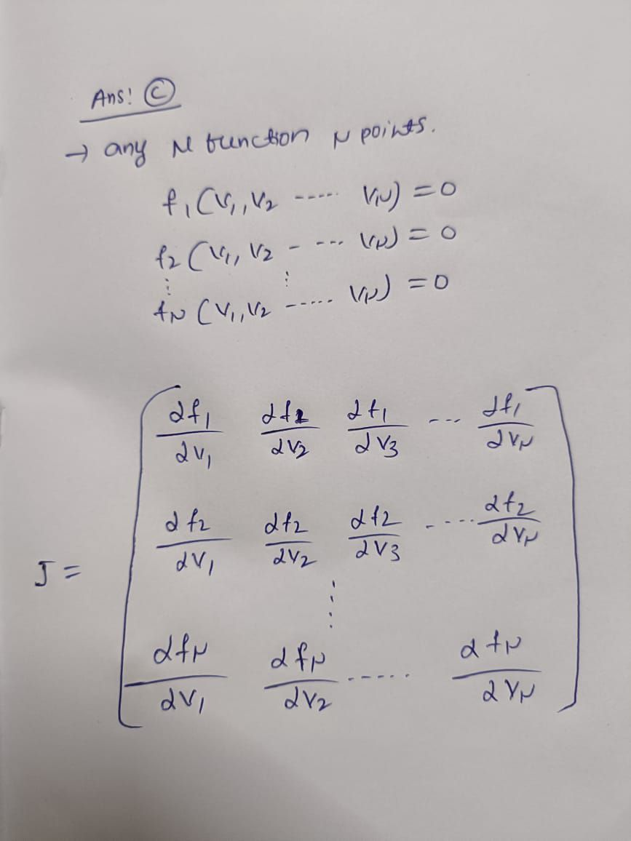

Q d. Consider a semiconductor (say, Silicon) of thickness 200m. Assume that one end (A) is

held at at 100mV while the other (B) is held at zero potential. Using a-c given above, solve for

this system using Newton’s method. Use a linearly varying potential profile as the initial guess.

Plot the potential and carrier density profiles.

ANS:

Code:

clear all;

clc;

q=1.6*(10)^(-19);

epsilon=11.8*8.85*(10)^(-12);

a=200*10^(-6);

h=a/1000;

ni=1.5*(10)^(16);

Vt=0.026;

k=(q*ni*(h)^2)/epsilon;

N=1000;

Va=0.1;

Vb=0;

V=linspace(Va,Vb,1000);

Z=V';

for i=1:1000

U(1,1)=0;

U(1000,1)=0;

for i=2:999

U(i,1)=Z(i+1)+Z(i-1)-2*Z(i)-(k*exp(Z(i)/Vt));

end

S(1,1)=1;

for i=2:1000

S(i,i)=-2-((k/Vt)*exp(Z(i)/Vt));

end

for i=2:999

S(i,i+1)=1;

end

for i=1:998

S(i+1,i)=1;

end

S(N,N)=1;

D=Z-inv(S)*U;

Z=D;

end

i=1:1000;

m=i*(a/1000);

plot(m,D);

xlabel('distance m (meter)');

ylabel('potential profile');

title('potential profile for 0.1V VS distance');

grid on;

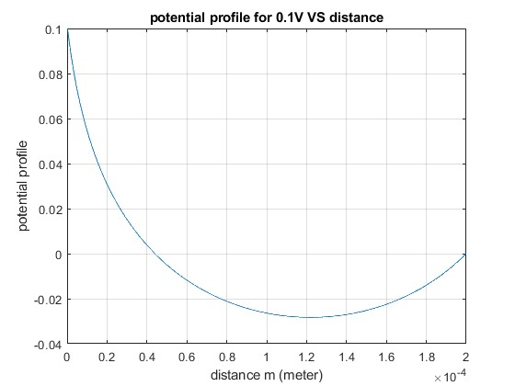

Carrier concentration:

clear all;

clc;

q=1.6*(10)^(-19);

epsilon=11.8*8.85*(10)^(-12);

a=200*10^(-6);

ni=1.5*(10)^(16);

h=a/1000;

Vt=0.026;

k=(q*ni*(h)^2)/epsilon;

N=1000;

Va=0.1;

Vb=0;

V=linspace(Va,Vb,1000);

Z=V';

for i=1:1000

U(1,1)=0;

U(1000,1)=0;

for i=2:999

U(i,1)=Z(i+1)+Z(i-1)-2*Z(i)-(k*exp(Z(i)/Vt));

end

S(1,1)=1;

for i=2:1000

S(i,i)=-2-((k/Vt)*exp(Z(i)/Vt));

end

for i=2:999

S(i,i+1)=1;

end

for i=1:998

S(i+1,i)=1;

end

S(N,N)=1;

D=Z-inv(S)*U;

z=D;

end

for i=1:1000

n=ni*exp(D/Vt);

end

i=1:1000;

m=i*(a/1000);

plot(m,n);

xlabel('distance(meter)');

ylabel('carrier concentration(atom/(meter)^3');

title(' carrier concentration for 0.1V VS distance');

grid on;

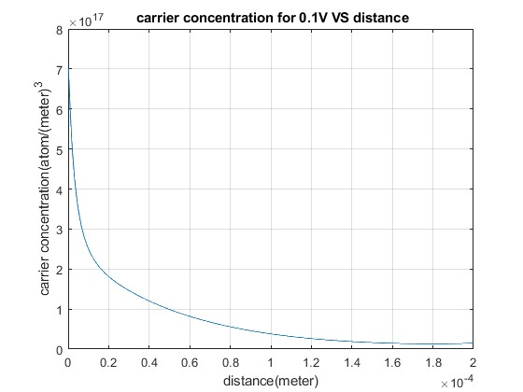

Qe. Repeat (d) for applied biases like 200mV, 400mV, and 600mV. Analyse your solutions.

ANS:

CODE:

FOR V=0.2V

POTENTIAL

clear all;

clc;

q=1.6*(10)^(-19);

epsilon=11.8*8.85*(10)^(-12);

a=200*10^(-6);

h=a/1000;

ni=1.5*(10)^(16);

Vt=0.026;

k=(q*ni*(h)^2)/epsilon;

N=1000;

Va=0.2;

Vb=0;

V=linspace(Va,Vb,1000);

Z=V';

for i=1:1000

U(1,1)=0;

U(1000,1)=0;

for i=2:999

U(i,1)=Z(i+1)+Z(i-1)-2*Z(i)-(k*exp(Z(i)/Vt));

end

S(1,1)=1;

for i=2:1000

S(i,i)=-2-((k/Vt)*exp(Z(i)/Vt));

end

for i=2:999

S(i,i+1)=1;

end

for i=1:998

S(i+1,i)=1;

end

S(N,N)=1;

D=Z-inv(S)*U;

Z=D;

end

i=1:1000;

m=i*(a/1000);

plot(m,D);

xlabel('distance m (meter)');

ylabel('potential profile');

title('potential profile for 0.2V VS distance');

grid on;

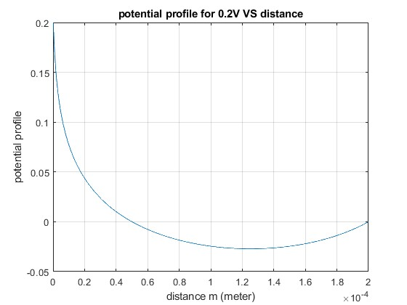

CARRIER DENSITY PROFILE

clear all;

clc;

q=1.6*(10)^(-19);

epsilon=11.8*8.85*(10)^(-12);

a=200*10^(-6);

ni=1.5*(10)^(16);

h=a/1000;

Vt=0.026;

k=(q*ni*(h)^2)/epsilon;

N=1000;

Va=0.2;

Vb=0;

V=linspace(Va,Vb,1000);

Z=V';

for i=1:1000

U(1,1)=0;

U(1000,1)=0;

for i=2:999

U(i,1)=Z(i+1)+Z(i-1)-2*Z(i)-(k*exp(Z(i)/Vt));

end

S(1,1)=1;

for i=2:1000

S(i,i)=-2-((k/Vt)*exp(Z(i)/Vt));

end

for i=2:999

S(i,i+1)=1;

end

for i=1:998

S(i+1,i)=1;

end

S(N,N)=1;

D=Z-inv(S)*U;

z=D;

end

for i=1:1000

n=ni*exp(D/Vt);

end

i=1:1000;

m=i*(a/1000);

plot(m,n);

xlabel('distance(meter)');

ylabel('carrier concentration(atom/(meter)^3');

title(' carrier concentration for 0.2V VS distance');

grid on;

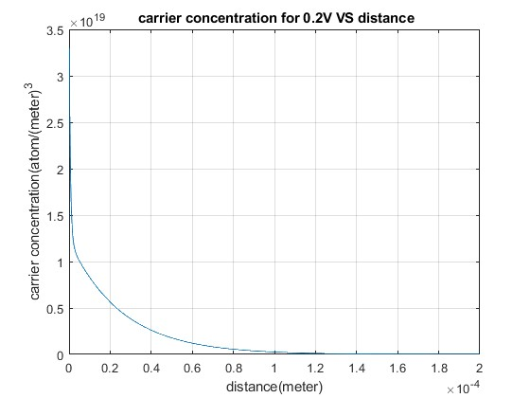

FOR V=0.4V

POTENTIAL

clear all;

clc;

q=1.6*(10)^(-19);

epsilon=11.8*8.85*(10)^(-12);

a=200*10^(-6);

h=a/1000;

ni=1.5*(10)^(16);

Vt=0.026;

k=(q*ni*(h)^2)/epsilon;

N=1000;

Va=0.4;

Vb=0;

V=linspace(Va,Vb,1000);

Z=V';

for i=1:1000

U(1,1)=0;

U(1000,1)=0;

for i=2:999

U(i,1)=Z(i+1)+Z(i-1)-2*Z(i)-(k*exp(Z(i)/Vt));

end

S(1,1)=1;

for i=2:1000

S(i,i)=-2-((k/Vt)*exp(Z(i)/Vt));

end

for i=2:999

S(i,i+1)=1;

end

for i=1:998

S(i+1,i)=1;

end

S(N,N)=1;

D=Z-inv(S)*U;

Z=D;

end

i=1:1000;

m=i*(a/1000);

plot(m,D);

xlabel('distance m (meter)');

ylabel('potential profile');

title('potential profile for 0.4V VS distance');

grid on;

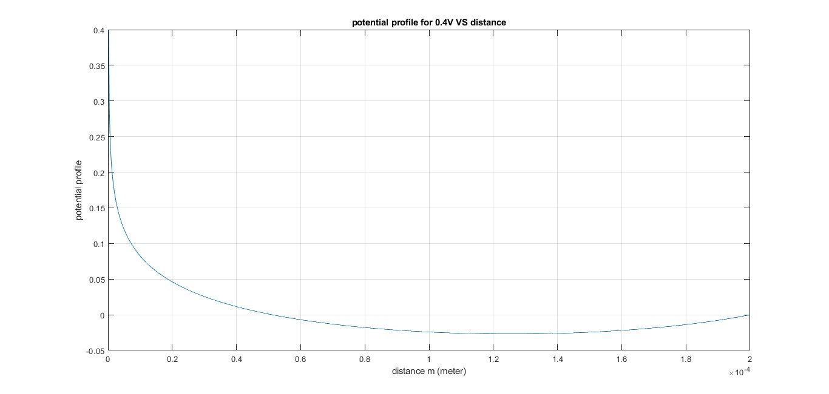

CARRIER DENSITY PROFILE

clear all;

clc;

q=1.6*(10)^(-19);

epsilon=11.8*8.85*(10)^(-12);

a=200*10^(-6);

ni=1.5*(10)^(16);

h=a/1000;

Vt=0.026;

k=(q*ni*(h)^2)/epsilon;

N=1000;

Va=0.4;

Vb=0;

V=linspace(Va,Vb,1000);

Z=V';

for i=1:1000

U(1,1)=0;

U(1000,1)=0;

for i=2:999

U(i,1)=Z(i+1)+Z(i-1)-2*Z(i)-(k*exp(Z(i)/Vt));

end

S(1,1)=1;

for i=2:1000

S(i,i)=-2-((k/Vt)*exp(Z(i)/Vt));

end

for i=2:999

S(i,i+1)=1;

end

for i=1:998

S(i+1,i)=1;

end

S(N,N)=1;

D=Z-inv(S)*U;

z=D;

end

for i=1:1000

n=ni*exp(D/Vt);

end

i=1:1000;

m=i*(a/1000);

plot(m,n);

xlabel('distance(meter)');

ylabel('carrier concentration(atom/(meter)^3');

title(' carrier concentration for 0.4V VS distance');

grid on;

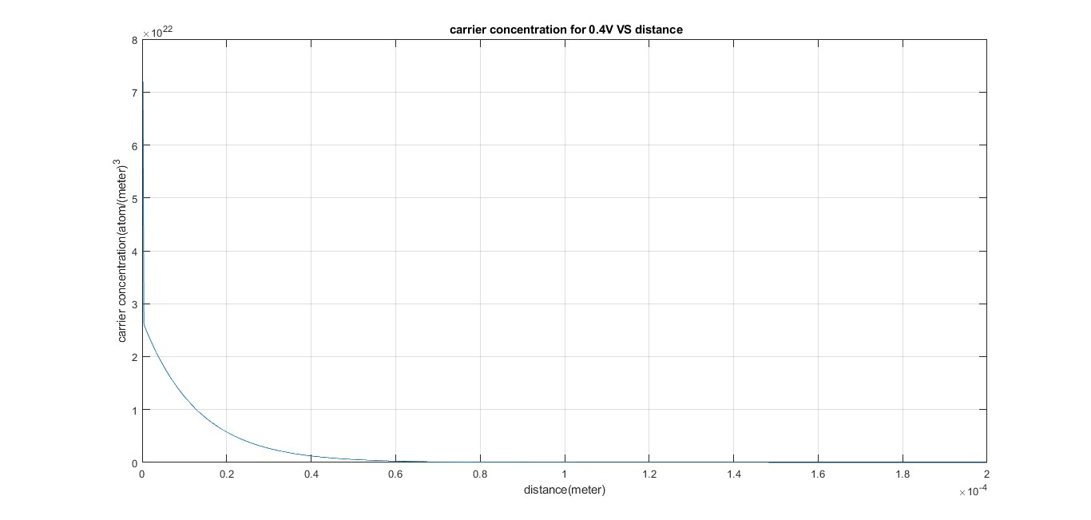

FOR V=0.6V

POTENTIAL

clear all;

clc;

q=1.6*(10)^(-19);

epsilon=11.8*8.85*(10)^(-12);

a=200*10^(-6);

h=a/1000;

ni=1.5*(10)^(16);

Vt=0.026;

k=(q*ni*(h)^2)/epsilon;

N=1000;

Va=0.6;

Vb=0;

V=linspace(Va,Vb,1000);

Z=V';

for i=1:1000

U(1,1)=0;

U(1000,1)=0;

for i=2:999

U(i,1)=Z(i+1)+Z(i-1)-2*Z(i)-(k*exp(Z(i)/Vt));

end

S(1,1)=1;

for i=2:1000

S(i,i)=-2-((k/Vt)*exp(Z(i)/Vt));

end

for i=2:999

S(i,i+1)=1;

end

for i=1:998

S(i+1,i)=1;

end

S(N,N)=1;

D=Z-inv(S)*U;

Z=D;

end

i=1:1000;

m=i*(a/1000);

plot(m,D);

xlabel('distance m (meter)');

ylabel('potential profile');

title('potential profile for 0.6V VS distance');

grid on;

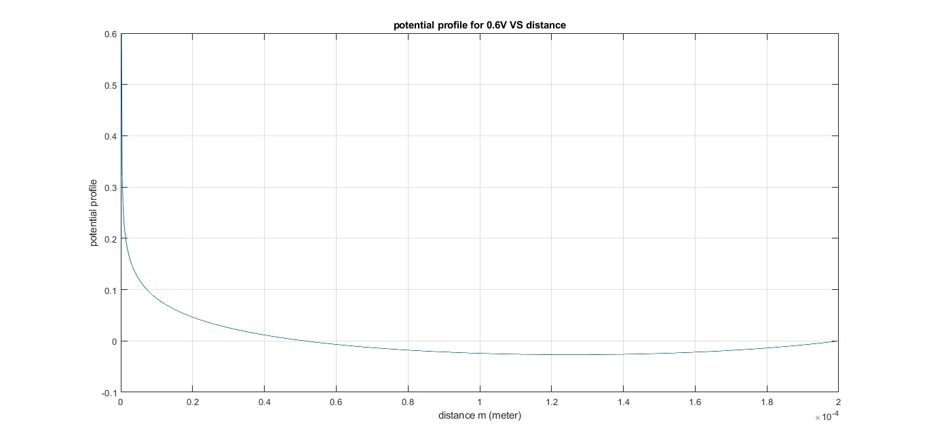

CARRIER DENSITY PROFILE

clear all;

clc;

q=1.6*(10)^(-19);

epsilon=11.8*8.85*(10)^(-12);

a=200*10^(-6);

ni=1.5*(10)^(16);

h=a/1000;

Vt=0.026;

k=(q*ni*(h)^2)/epsilon;

N=1000;

Va=0.6;

Vb=0;

V=linspace(Va,Vb,1000);

Z=V';

for i=1:1000

U(1,1)=0;

U(1000,1)=0;

for i=2:999

U(i,1)=Z(i+1)+Z(i-1)-2*Z(i)-(k*exp(Z(i)/Vt));

end

S(1,1)=1;

for i=2:1000

S(i,i)=-2-((k/Vt)*exp(Z(i)/Vt));

end

for i=2:999

S(i,i+1)=1;

end

for i=1:998

S(i+1,i)=1;

end

S(N,N)=1;

D=Z-inv(S)*U;

z=D;

end

for i=1:1000

n=ni*exp(D/Vt);

end

i=1:1000;

m=i*(a/1000);

plot(m,n);

xlabel('distance(meter)');

ylabel('carrier concentration(atom/(meter)^3');

title(' carrier concentration for 0.6V VS distance');

grid on;

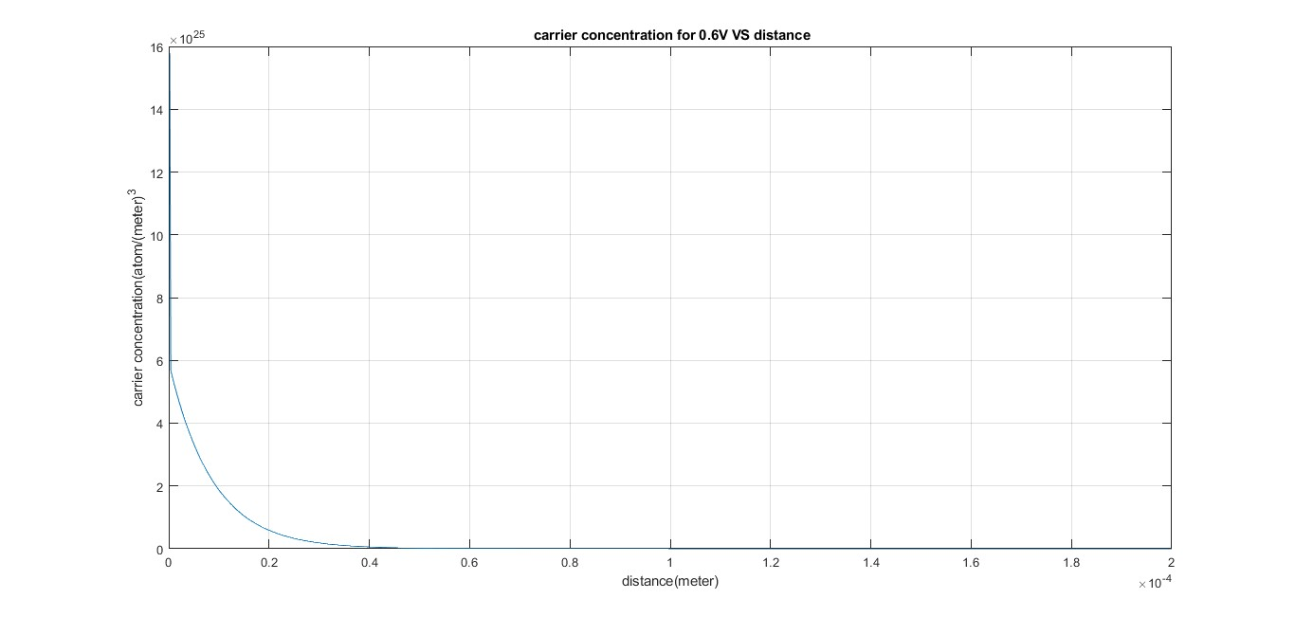

f. Assume that SiO2 of thickness 20nm is deposited at the end A and the potential is applied

across the SiO2 and the Semiconductor. Modify your code in (d) and find the carrier density

profiles inside the semiconductor for an applied bias of 1V. Comment on your results.

ANS